EXPERIMENT 6
PREM KARIRA
D15-B
27

AIM:To Connect Flutter UI with fireBase database

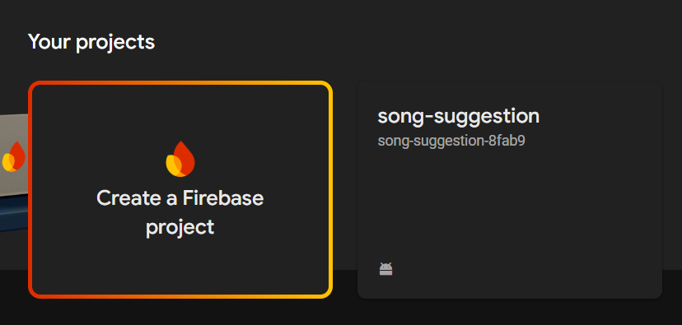
Connecting Flutter UI with Firebase (iOS & Android)
Firebase is a powerful backend-as-a-service (BaaS) that lets developers integrate key features like authentication, databases, and analytics into mobile apps. This guide walks you through connecting a Flutter app with Firebase for both Android and iOS platforms.

✨ Prerequisites
- Google account
- Flutter installed
- Android Studio & Visual Studio Code installed
- For iOS: Xcode installed
- Plugins:
  - Flutter and Dart (Android Studio)
  - Flutter extension (VS Code)

🎒 Create a Flutter Project
flutter create flutterfirebaseexample
cd flutterfirebaseexample

This creates a starter Flutter app ready for Firebase integration.

🏠 Set Up Firebase Project
- Visit Firebase Console
- Click Create Project, name it
- (Optional) Enable Google Analytics
- Wait for project setup, then go to the dashboard

📱 Android Setup
- Select the Android icon
- Enter your Android package name (e.g., com.example.flutterfirebaseexample)
- Update android/app/build.gradle with:
applicationId 'com.example.flutterfirebaseexample'

- Download google-services.json and place it in android/app/
- Update android/build.gradle:
classpath 'com.google.gms:google-services:4.3.6'

- In android/app/build.gradle, add:
apply plugin: 'com.google.gms.google-services'

- Add Firebase SDK dependencies:
implementation platform('com.google.firebase:firebase-bom:28.0.0')

📲 iOS Setup
- Go back to Firebase Console > Add App > Select iOS icon
- Use your iOS bundle ID (e.g., com.example.flutterfirebaseexample)
- Open ios/Runner.xcodeproj in Xcode
- Update the Bundle Identifier under General settings
- Download GoogleService-Info.plist and move it to the Xcode project root (Runner folder)

⚙️ Add FlutterFire Dependencies
Add to pubspec.yaml:
dependencies:
firebase_core: ^2.27.0
cloud_firestore: ^4.13.3

Then run:
flutter pub get

✨ Initialize Firebase in Flutter
Update main.dart:
void main() async {
WidgetsFlutterBinding.ensureInitialized();
await Firebase.initializeApp();
runApp(MyApp());
}

🎧 Example: Load Songs from Firestore (Optional)
Use StreamBuilder to fetch data from Firestore and display in your music app UI.

You now have Firebase connected to your Flutter project for both Android and iOS platforms. From here, you can add features like authentication, Firestore queries, analytics, or cloud functions.

Screenshot Preview:
